
Titel
Subtitle
Author
Document type – ex. Bachelor Thesis or Master Thesis
Main field of study: Computer engineering
Credits: ex. 15 or 30
Semester/year: ex. Spring/2024
Supervisor: Forename Surname
Examiner: Forename Surname
Course code: ex. DT099G or DT005A

At Mid Sweden University, it is possible to publish the thesis in full text in DiVA (see appendix for publishing conditions). The publication is open access, which means that the work will be freely available to read and download online. This increases the dissemination and visibility of the degree project.
Open access is becoming the norm for disseminating scientific information online. Mid Sweden University recommends both researchers and students to publish their work open access.
I/we allow publishing in full text (free available online, open access):
☐ Yes, I/we agree to the terms of publication.
☐ No, I/we do not accept that my independent work is published in the public interface in DiVA (only archiving in DiVA).

Location and date

Programme/Course

Name (all authors names)
Year of birth (all authors year of birth)
Abstract
The report shall include two abstracts, one in Swedish and one in English. The abstract acts as a description of the report’s contents. This allows for the possibility to have a quick review of the report and provides an overview of the whole report, i.e. contains everything from the objectives and methods to the results and conclusions. Examples: “The objective of this study has been to answer the question…. The study has been conducted with the aid of…. The study has shown that…” Do not mention anything that is not covered in the report. An abstract is written as one piece and the recommended length is 200-250 words. References to the report's text, sources or appendices are not allowed; the abstract should “stand on its own”. Only use plain text, with no characters in italic or boldface, and no mathematical formulas. The abstract can be completed by the inclusion of keywords; this can ease the search for the report in the library databases. The keywords should be listed in order of importance.
Keywords: Human-computer-interaction, XML, Linux, Java.

Sammanfattning
Also write the abstract in Swedish. If you write your thesis in Swedish, Sammanfattning should be before Abstract.

Nyckelord: Människa-dator interaktion, XML, Linux, Java.

Acknowledgements / Foreword
(Swedish: Förord) Acknowledgements or Foreword (choose only one of the heading alternatives) are not mandatory but can be applied if you as the writer wish to provide general information about your exam work or project work, educational program, institution, business, tutors and personal comments, i.e. thanks to any persons that may have helped you. Acknowledgements are to be placed on a separate page.
Table of Contents
Sammanfattning 3
Acknowledgements / Foreword 4
Terminology / Notation 7
1 Introduction 1
1.1 Background and motivation 1
1.2 Overall aim and problem statement 1
1.3 Research questions/Scientific goals/Verifiable goals 1
1.4 Scope 2
1.5 Usage of AI tools in this thesis 2
1.6 Outline 2
1.7 Division of work 2
2 Theory 3
2.1 The scientific base of the research area 3
2.2 Other relevant background knowledge 3
2.3 Related work 3
2.3.1 Example of a related work domain 3
2.3.2 Another example of related work domain 3
2.3.3 Etc. until all related works has been covered 4
3 Methodology 5
3.1 Scientific method description 5
3.2 Project/Work method description 5
4 Choice of approach/System design/Pre-study 7
4.1 Requirements capturing/Approach alternatives 7
4.1.1 Requirement X/Approach X 7
4.1.2 Another requirement/alternative 7
4.1.3 Etc. until all has been covered 7
4.2 Requirement analysis/Comparison of approaches 7
4.3 Proposed/Chosen approach 7
5 Implementation 8
5.1 First part of the overview figure 8
5.2 Another part of the overview figure 8
5.3 Etc. until all parts are covered from the overview figure 8
5.4 Measurement/Evaluation setup 8
6 Results 9
6.1 Resulting application/system 9
6.2 Measurement results 9
7 Discussion 11
7.1 Analysis and discussion of results 11
7.2 Project/Work method discussion 11
7.3 Scientific discussion 11
7.4 Consequence analysis/Recommendation 11
7.5 Ethical and societal discussion 11
8 Conclusions 12
8.1 Future work 12
8.1.1 Example of a future work 12
8.1.2 Another example of a future work 12
8.1.3 Etc. until all future works has been covered 12
References 13

Terminology / Notation
(Swedish: Terminologi/Notation) Choose one of the headline alternatives. A possible list of terms, abbreviations and variable names with brief explanations may be placed after the table of contents but is not required. Note that although a term is explained in the list of terms, it should also be explained in the chapter text where it is used the first time. This list shall be in alphabetical order.
Acronyms/Abbreviations
ACK Acknowledge.
AWGN Additive White Gaussian Noise
Mathematical notation
G(x) RC generator polynomial
- Introduction
(Swedish: Introduktion) A brief introduction of your work and this chapter. Shortly explain the overall context surrounding your work. Explain if it is a project proposed by a company or from a research group.
  - Background and motivation
(Swedish: Bakgrund och motivation) Explain the background and the motivation for this work. In this sub-chapter you should try to quickly engage the readers' interest in the problem area you have chosen to examine. Demonstrate that you are familiar with the technical problem, and that you understand the context in which your problem emerges, that you can also describe it from a non-technical perspective, and that you are aware of the practical benefits of the technology you are examining. It is common that the first sentence contains an insightful formulation or historical retrospective.
  - Overall aim and problem statement
(Swedish: Syfte och problemformulering) Explain why we are doing this, the higher reason for this work i.e. the purpose. The project's aim should be written as an insightful description of the direction in which you want to work, your hopes with regards to the possible outcomes of the project, and of the projects' higher purpose. Be visionary and futuristic regarding the end goal of the thesis.
Make a clear problem statement. Preferably in the form: The investigated problem of this thesis is… The specified area must be answered later in the report's results and in its conclusion. The problem statement should be so clearly defined, that deciding whether or not the problem has been resolved should be easy and understandable.
  - Research questions/Scientific goals/Verifiable goals
(Swedish: Forskningsfrågor/Vetenskapliga mål/Verifierbara mål) Choose only one of the headlines. Split this hard problem into a number of achievable, concrete, measurable, and verifiable scientific goals or a number of research questions that you will answer. Use adjectives and quantify them when possible. Explain what the scientific knowledge gained from this work will be.
- ???
- ???
- ???
  - Scope
(Swedish: Avgränsningar) Explain what you have focused your work on and what you have chosen to not focus on. What will be in focus? What will not be in focus?
  - Usage of AI tools in this thesis
Explain how and if you will bee using AI tools like ChatGPT, Gemini, Copilot, in thesis. Make a brief overview on how you have used these tools to assist you in the work of this thesis. Did you use them for text creation, text correction, for programming, for idea generation, etc.
  - Outline
(Swedish: Översikt) Briefly describe the report's outline. Begin with Chapter 2 in this way: “Chapter 2 describes…”
  - Division of work
(Swedish: Fördelning av arbetet) Describe which parts of the work that you have conducted yourself, and which parts that you had help with i.e. was carried out by colleagues or with extensive external aid. If the work is carried out in a group, this section should explain how the overall tasks were divided between authors. If you have done all the work yourself and has had no external aid, you can remove this section.
- Theory
(Swedish: Teori) Summarize and introduce the theory chapter. The report’s theory chapter should contain additional facts required for the reader's understanding of the remainder of the report. At this point a summary of background material in the area should be provided, i.e. standards, scientific articles, books, magazines, documents on the web, technical reports and user manuals. Explain pedagogically with clear examples and many illustrations. It should be demonstrated that you have an awareness of the context and the background of your work. Also explain the aim of the technology that you describe, and not only how the technology works.
  - The scientific base of the research area
Should be changed to whatever the area is called. For example: Machine Learning, Internet-of-Things, Visualization, Network Communication, etc. One good place to find good articles for this section is to search on Google Scholar for your research area with the added keyword ‘survey’.
  - Other relevant background knowledge
Continue with more relevant theory, background knowledge, and technologies so that the reader can understand the rest of this thesis.
Continue the theory chapter with more headings as needed.
  - Related work
(Swedish: Relaterat arbete) End the theory chapter with a section called related work. Find a number of scientific related works/”competitors”. Meaning other works that have done something similar to what you have done. One good place to begin this is work is by searching for similar works to yours on Google Scholar.
    - Example of a related work domain
Explain how your work will be similar and how you work will be different from their work. Put your work into relation to theirs.
Continue the list with one heading for each concrete piece of related work.
    - Another example of related work domain
Explain another related work.
    - Etc. until all related works has been covered
Explain another related work. Etc.
- Methodology
(Swedish: Metod) Summarize and introduce the methodology chapter. The method section is the point at which your chosen method and intended procedure are presented. This section should contain information for the reader to interpret your results and repeat your work, i.e. in order to check the results. Here, the tools, assumptions, mathematical models, performance measures and assessment criteria are presented.
  - Scientific method description
(Swedish: Vetenskaplig metod) Explain your scientific method. Will you be using a quantitative or qualitative method? Most works in computer engineer will be quantitative studies. Will you follow the design science methodology or some other methodology, such as action research method, descriptive research design, correlational research design, or experimental research design.
Explain how you will scientifically attack and work with each of the scientific goals/research questions. One paragraph per goal/question is often enough.
  - Project/Work method description
(Swedish: Projektmetod/Arbetsmetod) Explain your project and/or working method. Split the work into a number of achievable milestones/phases.
Many theses work in computer engineering typically follow either a waterfall inspired method akin to the structure of this report: Theory (in which you will gain more knowledge about the requirements to be able to solve the problem), Pre-study (where you will further refine analyze your requirements, approach, design, etc.), Implementation (where you will build some artifact), Measure (in which you will perform measurements on your artifact), and Evaluate (where you will analyze and evaluate your results and measurements).
Or a design science inspired structure: Identify problems (in which you define the problem and show importance), Define objectives (in which you define requirements, etc.), Design & development (where you will build some artifact), Demonstration (where you use the artifact to solve the problem), Evaluation (where you observe its effectiveness), Communication (making your results public).
Sometimes a more design-based research method is applied: Grounding (where you start by setting the basis and settings for the work), Conjecturing (where you make initial an embodiment and assertions), Iteration (where you iteratively create, test, and re-conjecture, to gather data), and finally Reflecting (where you reflect upon your design and results).
And sometimes a more design thinking inspired structure: Empathize (where you gain real insight into users and their needs), Define (where you define the problem statement in a human-centered manner.), Ideate (where you identify innovative solutions to the problem statement you’ve created), Prototype (where you create possible solutions), Test (where you test solutions to derive a deep understanding of the product and its users).
Explain how you will work and do within each of these milestones/phases. Justify your choice of methodology/model. What metrics will you use to evaluate your work? Comment on the method's possible weaknesses and problems that may arise during actual implementation. A flowchart can help in visualizing the phases/milestones. One paragraph per milestone/phase is often enough to write.
- Choice of approach/System design/Pre-study
(Swedish: Val av angrepssätt/Systemdesign/Inledande studie) Choose only one of the headlines. This chapter will be substantially different depending on your thesis topic, direction, and scientific level. But in this chapter, you will present the different options you have faced and made your choice between, or you will explain the work that has led up to your implementation, and your analysis of different requirement.
  - Requirements capturing/Approach alternatives
(Swedish: Kravfångst/Angreppsalternativ) Explain the requirement capturing and the identified requirements, or the different approach alternatives.
    - Requirement X/Approach X
Present and summarize the potential approaches or requirements that you have considered. Make them even in length and style, to be of equal in importance.
Continue the list with all alternatives/requirement, one heading for each.
    - Another requirement/alternative
Another requirement or potential approach.
    - Etc. until all has been covered
Another, etc.
  - Requirement analysis/Comparison of approaches
(Swedish: Kravanalys/Jämförelse av angreppssätt) Analyze the identified requirements, compare different approaches to another, benefits, drawbacks? Pros vs cons? A table for clear comparison can be used, for example a Pugh matrix.
  - Proposed/Chosen approach
(Swedish: Föreslagen/Utvalt angreppssätt) Present your proposed or chosen approach. It is very important to motivate why this was chosen over the others. Connect back to your overall aim and problem statement, to ensure that the chosen approach actually can answer your scientific goals/research questions.
- Implementation
(Swedish: Implementation) Choose only one of the headlines. In this chapter you will explain all the technical details of your work. Start this chapter with an overview of your work and an overview block figure with the protocols, algorithms, and technologies written out. Basically, as form of UML component diagram. You can also use storyboards, mock-up designs, state diagrams to show the overall structure. See Figure 1 for an example. All figures and tables must be referenced from the text.
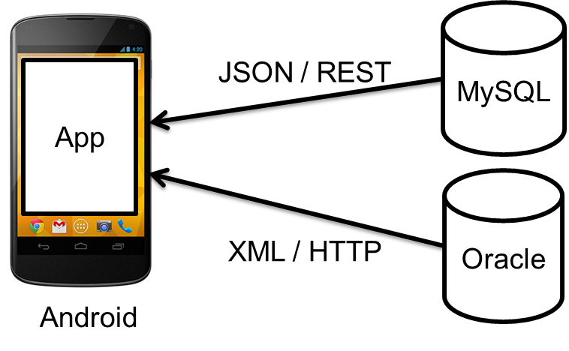
Figure 1: System overview
  - First part of the overview figure
Use a top-down approach, divide and conquer, split the figure into relevant pieces. Explain each piece in detail, use titles that can be found in the overview figure. Use flow charts, UML diagram, pseudocode etc. but no real code. Refer to the appendix for the actual source code. Motivate your implementation choices.
  - Another part of the overview figure
Another piece of the solution.
  - Etc. until all parts are covered from the overview figure
Another piece of the solution. Etc.
  - Measurement/Evaluation setup
(Swedish: Mätuppställning) Remember to explain how you will measure/evaluate your implementation and how your test bench has been built/setup/implemented.
- Results
(Swedish: Resultat) Summarize and introduce your results
  - Resulting application/system
(Swedish: Färdiga applikationen/systemet) Present your resulting work. Screenshots, features, etc.
  - Measurement results
(Swedish: Mätresultat) Present your measurements. How well does it perform? Present the results objectively, with as little bias as possible. Use tables, graphs, etc.
You can find an example table below. See Table 1.
Table 1. Measured times for the model.
 | Shortest  (ms) | Longest  (ms) | Average  (ms) | Stdev  (ms)
Model one | 10 | 30 | 20 | 5
Model two | 20 | 40 | 35 | 3

Here is an example of a line graph. See Figure 2.
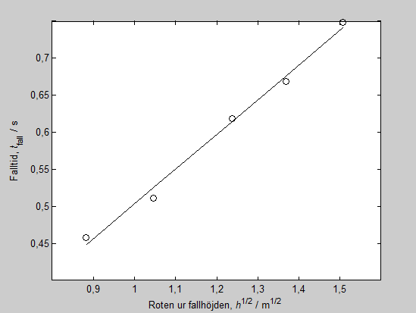
Figure 2: Line graph example.
Here is an example of a bar chart with standard deviation whiskers. See Figure 3.
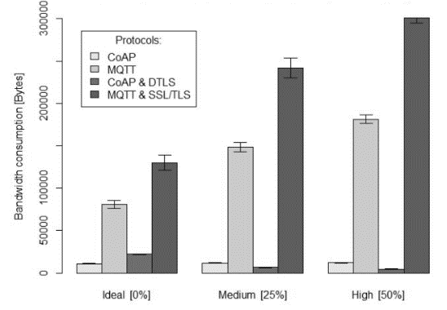
Figure 3: Bar chart example.

Below is an example boxplot. See Figure 4.
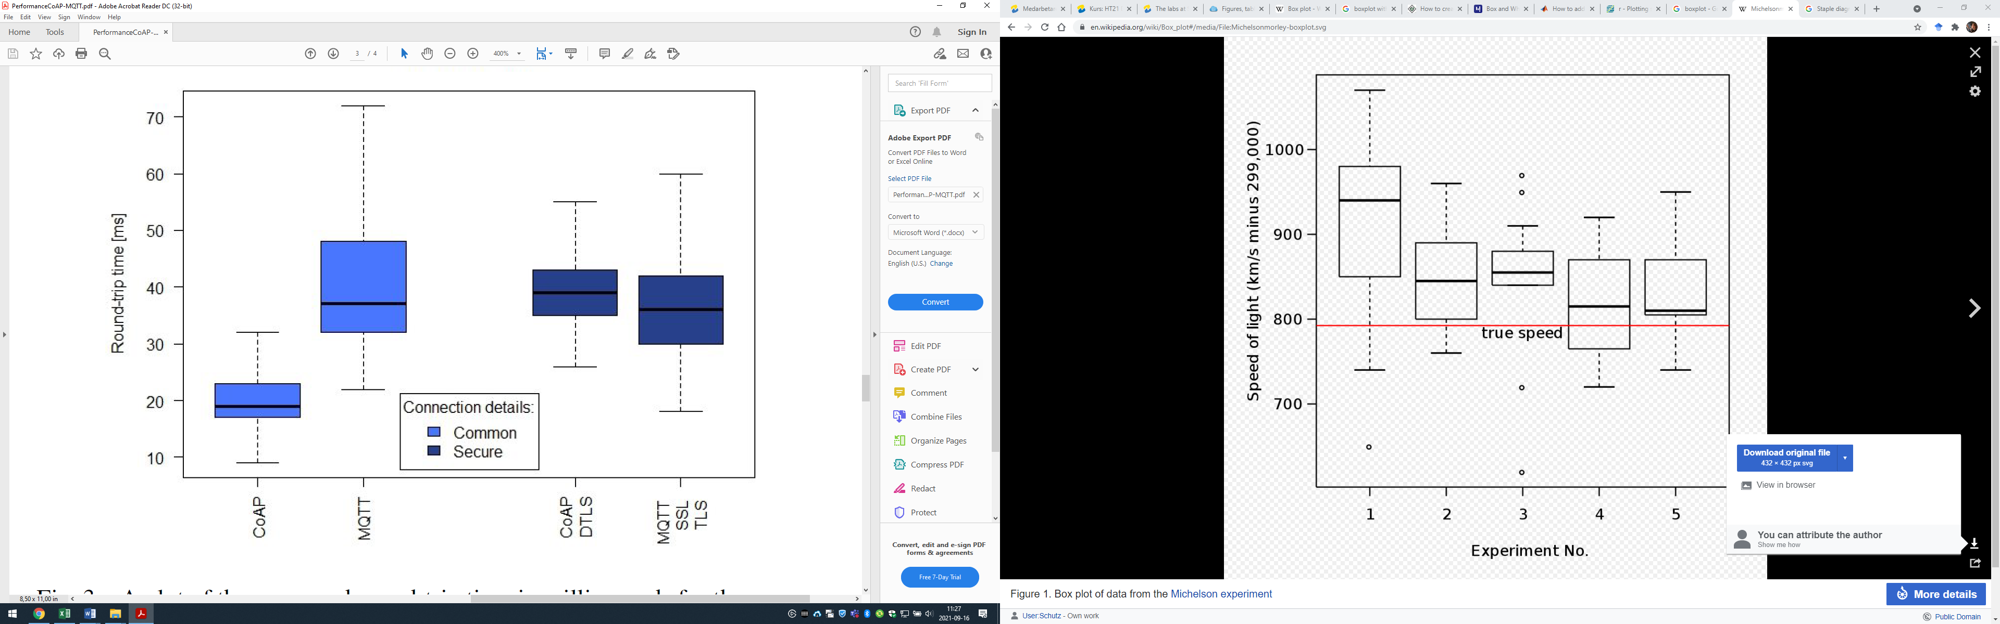
Figure 4: Boxplot example.

And here is an example equation. See Equation 1.
, (1)
- Discussion
(Swedish: Diskussion) Summarize and introduce what you will discuss and analyze.
  - Analysis and discussion of results
(Swedish: Diskussion och analys av resultat) Make a deep analysis and discussion of your resulting application, measurements, evaluation, etc. Here it is ok to be more subjective/biased.
This section can and should be quite long.
  - Project/Work method discussion
(Swedish: Metodsdiskussion) Make a deep analysis and discussion of your chosen method, chosen approach, chosen metrics, etc. Connect back to 3.2.
Discuss all of your project milestones/phases. Have they been successful?
  - Scientific discussion
(Swedish: Vetenskaplig diskussion) Make a deep discussion of the gained scientific knowledge and your scientific method. Answer and discuss your original research questions/scientific goals/verifiable goals. What can be learnt? Is this knowledge general or specific, etc. Make a discussion by looking back at the related works and put your work into perspective. Remember to discuss and show insights into the scientific possibilities of this work and its limitations.
  - Consequence analysis/Recommendation
Discuss the scientific impact and the contribution of your work. What will be the consequences of this new knowledge? If you are working with an industry problem, what do you recommend the company to continue to pursue?
  - Ethical and societal discussion
(Swedish: Etiska och samhälleliga aspekter) You will need to include a discussion on ethics, societal impact, and considerations. Use the human perspective, how will we be affected by this work, was people involved in the process, privacy? Remember to discuss and show insights into this project’s role in society and our responsibilities for how it is used.
- Conclusions
(Swedish: Slutsats) Summarize your outcome and wrap up all loose ends. Make clear conclusions regarding your goals, research questions and problem statement. Include your scientific contribution and impact.
Shortly give an answer to all of your research questions/scientific goals/verifiable goals. Have they been met?
Remember to also give an answer to your problem statement.
  - Future work
(Swedish: Framtida arbete) You should also explain potential future work based on your work. What new research problems or potential project have arisen after you have finished? If someone were to continue your work, what should they do?
    - Example of a future work
Remember to not just point out potential future work, also explain how you would approach this particular future work if you had the opportunity to do so.
    - Another example of a future work
Another aspect to do future work on.
    - Etc. until all future works has been covered
Explain another aspect to do future work on. Etc.

References
(Swedish: Referenser) Below is an example of a numbered list of references according to the IEEE reference standard used in technical reports (Vancouver system).
- J. Attapangittya, “Social studies in gibberish,” Quarterly Review of Doublespeak, vol. 20, no. 1, pp. 9-10, 2003. (Example of a reference to article in scientific journal)
- J. Smith, R. Jones, and K. Trello, “Adaptive filtering in data communications with self improved error reference,” In Proc. 15th IEEE Int. Conf. Wireless Communications, 2004, pp. 65-68. (Example of a reference to an article in a scientific conference)
- R. Hayes, G. Pisano, and S. Wheelwright, Operations, Strategy, and Technical Knowledge. Hoboken, USA: Wiley, 2007. (Example of a reference to a book)
- C. Wilson-Clark, “Computers ranked as key literacy,” The Atlanta Journal Constitution, para. 3, March 29, 2007. [Online], Available: http://www.thewest.com.au [Accessed Sept. 18, 2007]. (Example of a reference to an online source)
- N. Kawasaki, “Parametric study of thermal and chemical nonequilibrium nozzle flow,” M.S. thesis, Dept. Electron. Eng., Osaka Univ., Osaka, Japan, 1993. (Example of a reference to another thesis)

Appendix A: Source Code
(Swedish: Bilaga) Avoid using actual program code in the report. Instead, provide a link here to a repository or someplace where the code can be downloaded. But remember that you must mention this appendix somewhere in the report e.g. For the complete source code, see Appendix A.

